CREATING A RESOURCE PLATFORM FOR
THE FIRST TIME?
THIS IS YOUR ULTIMATE 101 GUIDE
By KULU - Women and Development
Drawn from the experiences of KULU’s resource platform created for last year’s webinar series on migrant women’s democratic rights, economic empowerment and storytelling, this guide serves as a beginner’s guide to creating relevant resource platforms for your target audience. This guide may be especially useful for civil society, grassroots movements and non-profit organisations.

What is a Resource Platform and Why is it Important?
A resource platform is an online hub designed to provide valuable information, tools, and materials tailored to a specific target audience. It can include articles, videos, downloadable resources, interactive tools, and forums for discussion.

For civil society, grassroots movements, and non-profit organisations, a well-crafted resource platform can enhance project visibility, foster community engagement, and facilitate knowledge sharing. By centralising resources in an accessible and user-friendly manner, it has the potential to empower your target audience with the information they need to take informed actions, support the organisation's mission, and strengthen its impact.
____________________________________________________________________________

First Steps: Overview and Coordination
When planning to set up a resource platform you must identify the foundational pillars:
- Where will the resource platform be hosted?
- What categories and types of content will the resource platform include?
- Who is your target audience?
- Why are we creating the resource platform?
In addition to identifying the answers to the questions above, it is important to create a space for documentation and coordination of the work that has been done, is in progress, and is to be done. If your organisation already is working with a preferred project management/coordination method, maintain that method. If not, you can consider exploring platforms such as Trello, Notion, Monday - or just a classic notebook or shared Google document/folder.
____________________________________________________________________________

Where: Choosing a Hosting Platform
When deciding where to host your resource platform, it's essential to consider your organisation's budget and technical expertise. While some might assume that creating an effective online resource hub requires substantial financial investment and advanced technical skills, this is not necessarily the case.
Many cost-effective and user-friendly options are available, making it feasible for organisations with limited budgets and technical knowledge to create a professional and accessible platform. From open-source content management systems to intuitive website builders, these tools allow you to develop a robust resource platform that meets your audience's needs without straining your resources.
When discussing where to host the resource platform, consider the following:
- Existing Subscriptions: Utilise existing subscriptions like Wix, WordPress, or Squarespace if available.
- Scalability and Flexibility: Choose a platform that can scale with your needs and offers flexibility in terms of design and content management.
- Specific Features: Consider features such as multimedia support, user engagement tools (like comments or forums), and integration with social media and mailing lists.
If your organisation does not have any subscriptions and no budget, Canva is your solution. Canva for Nonprofits offers access to all the premium features - 100% free. All you need to do is apply here. While Canva might be known for creating graphical cards and documents, they also have a website hosting platform - this is what KULU used for their resource platform in the We Empower-project.
____________________________________________________________________________

Content: What, Who, and Why
Once all the practical and technical matters have been covered, focus on the actual content of the platform. This part of the work will define the platform’s value for your target audience.

Who is your target audience?
- Audience Analysis: Conduct an analysis of your target audience to understand their needs, preferences, and behaviours.

What content will the resource platform include?
- Relevance: Ensure the content is time-relevant, aligned with your audience’s interests, and pertinent to your organisation’s goals.
- Variety: Include diverse types of content such as articles, videos, infographics, and downloadable resources.
- Quality: Maintain high-quality standards in all content to ensure credibility and usefulness.

Why are we creating the resource platform?
- Purpose and Goals: Clearly define the purpose of the platform and the goals you aim to achieve. This could be to educate, inform, provide support, or foster community engagement.
- Problem Solving: Identify the problems or gaps the resource platform aims to address and how it will benefit the target audience.
____________________________________________________________________________

Example: KULU’s resource platform for migrant women
Link to the Danish website: https://we-empower-ressourcer.my.canva.site/home
For the purpose of this guide, kindly see below to view the English translation of the website as well as explanations of the structure:
Landing page (images in carousel format if possible)
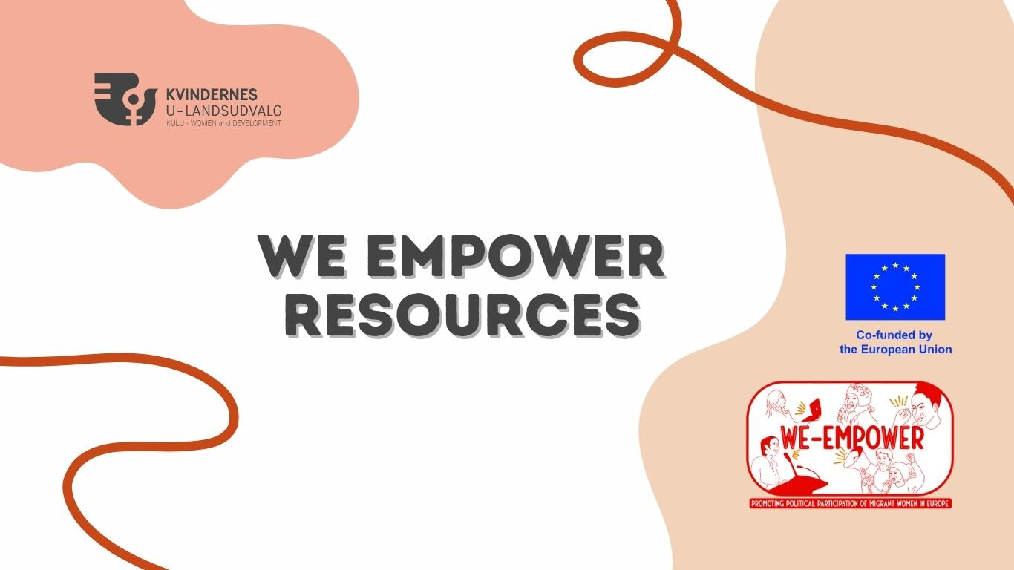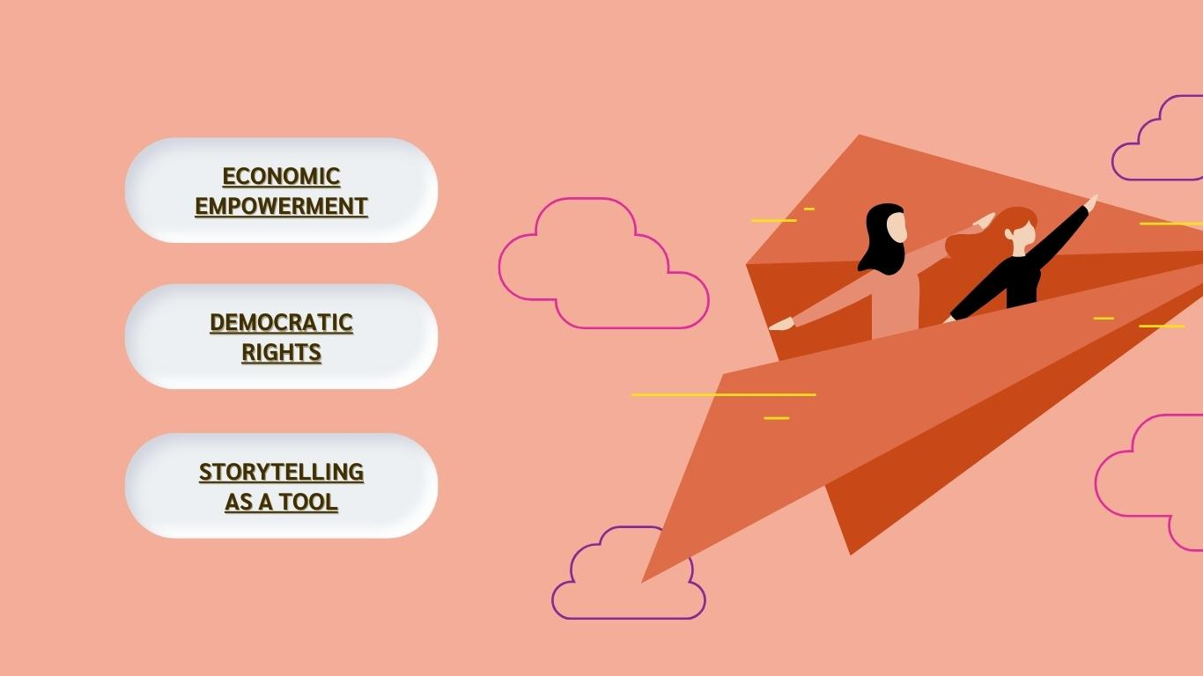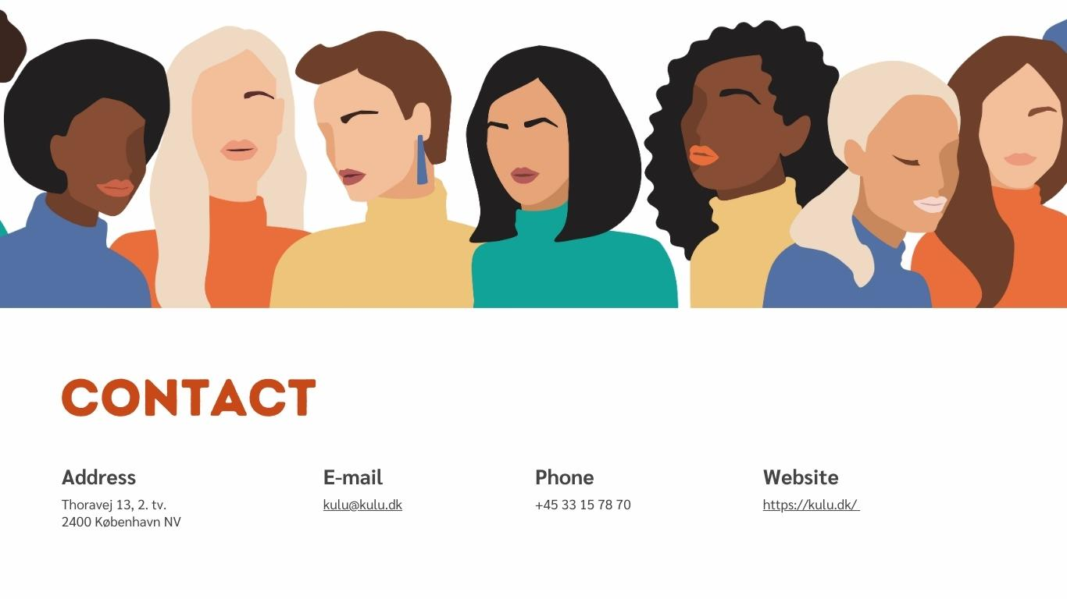 | Creating a simple yet eye-catching landing page is crucial for capturing and maintaining your audience’s attention. The landing page serves as the first impression of your resource platform, and a well-designed, intuitive layout can significantly enhance user experience. A clean, visually appealing landing page ensures that visitors can easily navigate the site, find the information they need, and engage with your content. By balancing simplicity with engaging design elements, you can create a welcoming and professional gateway to your resource platform that encourages users to explore further.  For this landing page, KULU developed an overarching visual identity for both the webinar series and the resource platform as to visually relate both initiatives.  The target audience being migrant women and professionals working with migrant women, it was important to include elements to which the target audience directly can relate.  Since the three webinars in the webinar series touched upon three different topics, we decided that the resource platform should follow the same structure and be divided into three themes: economic empowerment, democratic rights and storytelling as a tool.
Topic 1: Economic Empowerment (images in carousel format if possible)
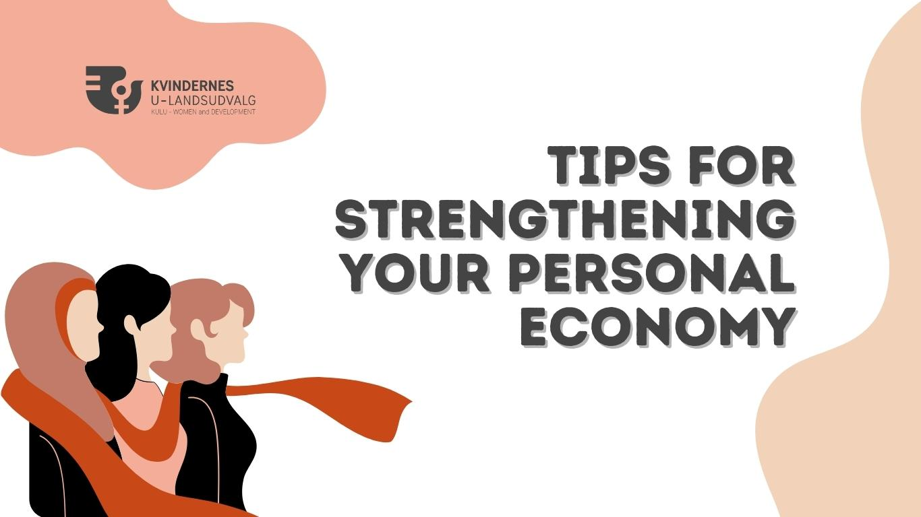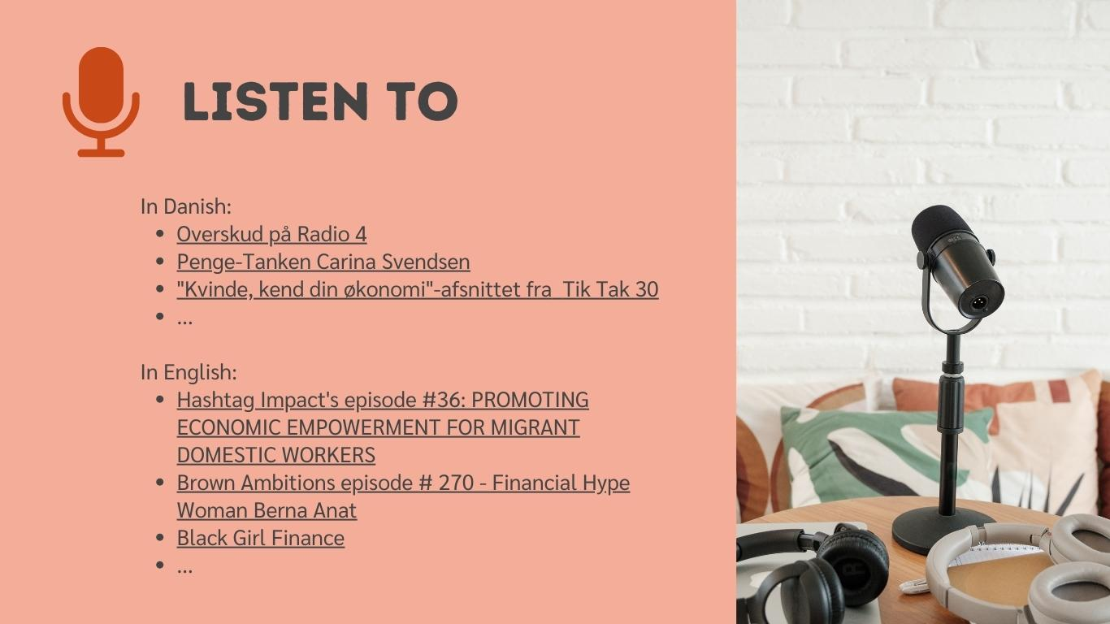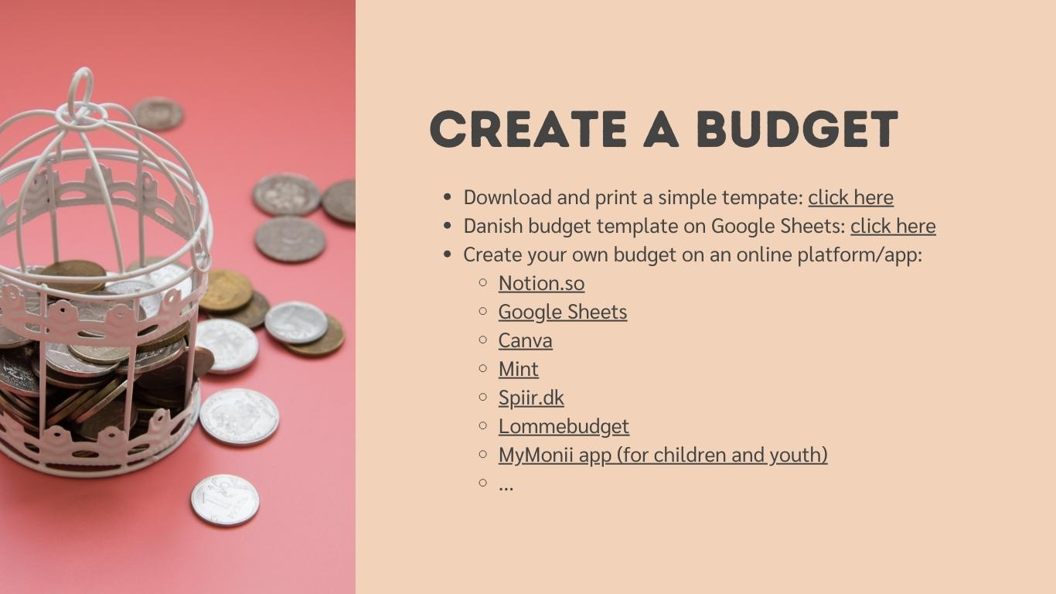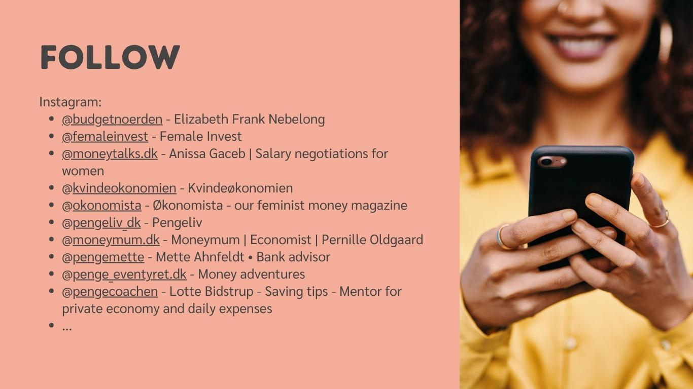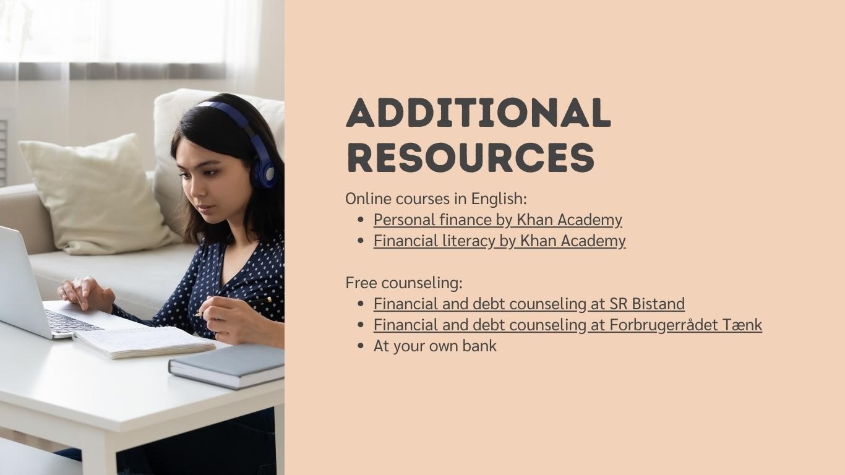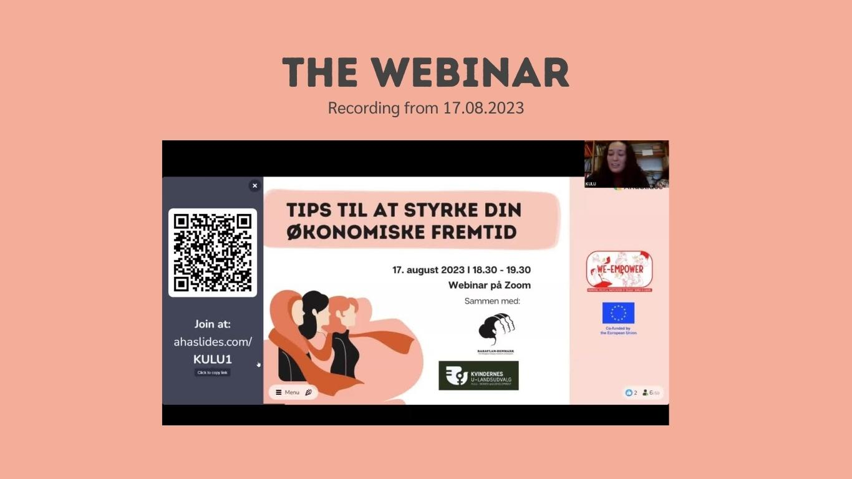 | Each of the themes contains the same foundational structure, which then was adapted according to the theme.  For the economic/financial resources, we created the following categories:  - “Listen to” with podcast suggestions in both English and Danish.  - “Create a budget” with various budgeting resources, including a downloadable printing file, an online template and links to existing budgeting platforms and mobile apps.  - “Follow” linking to suggested Instagram accounts that specialise in financial literacy and personal economy.  - “Additional resources” with free online courses and free, local counseling opportunities in Copenhagen.  - “The webinar” with the webinar recording.
Topic 2: Democratic Rights (images in carousel format if possible)
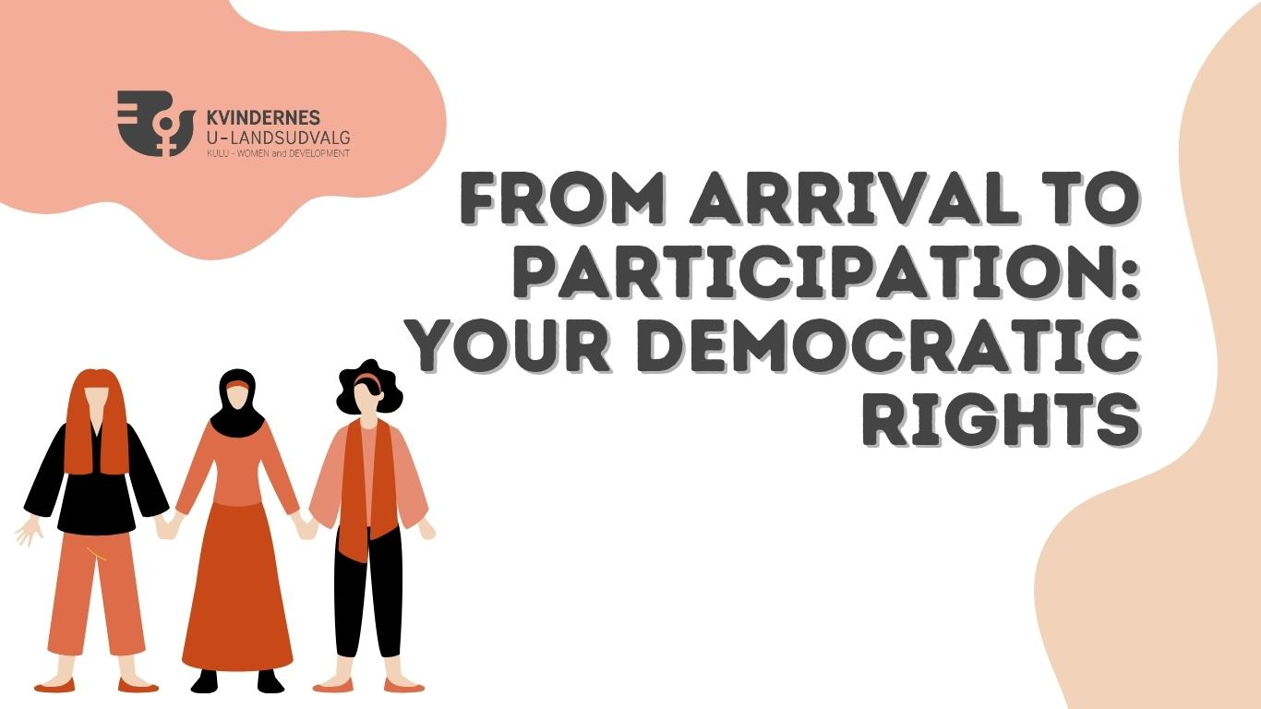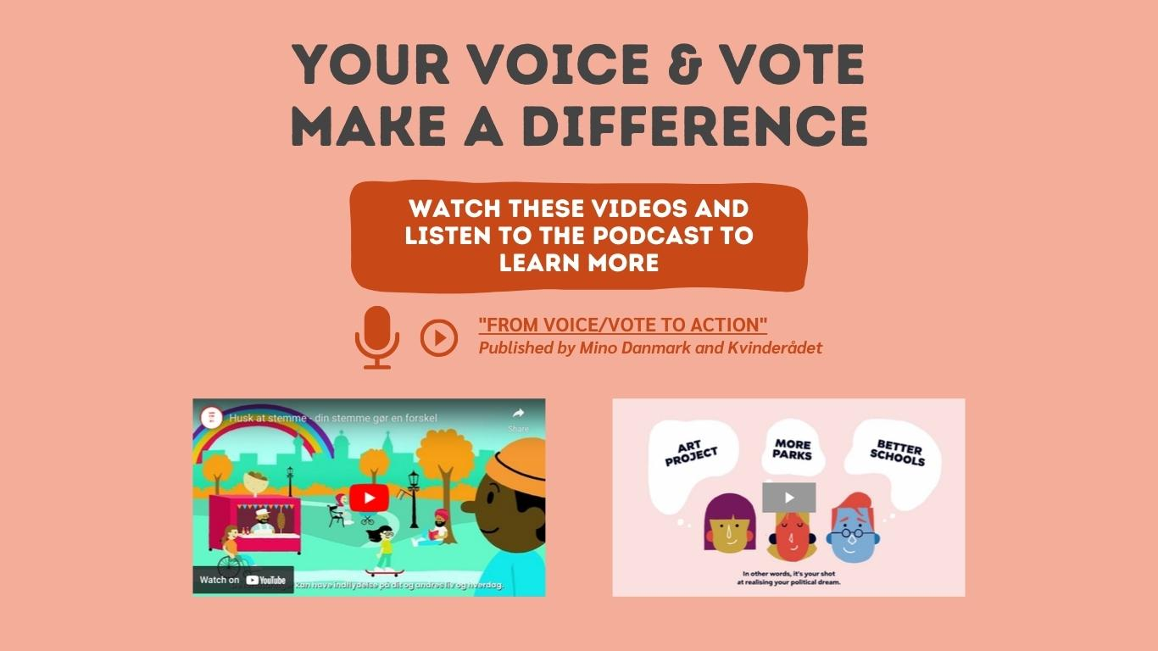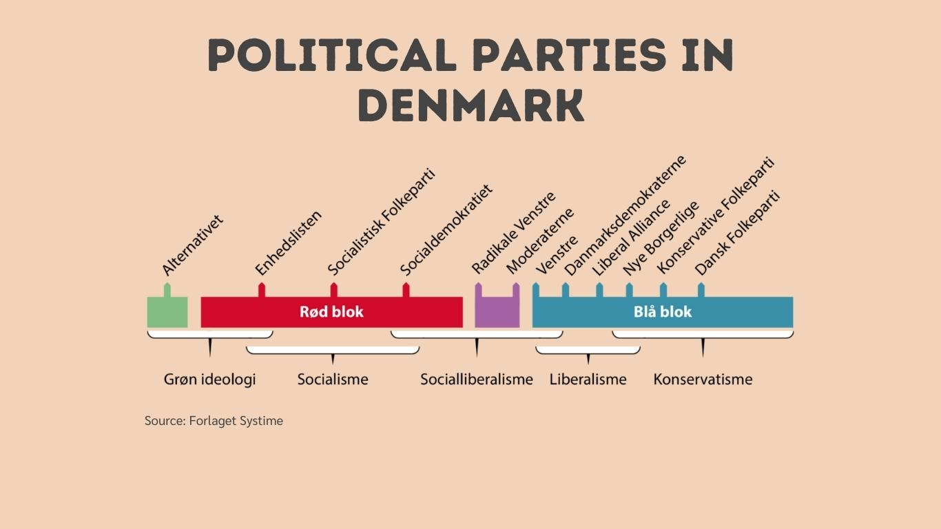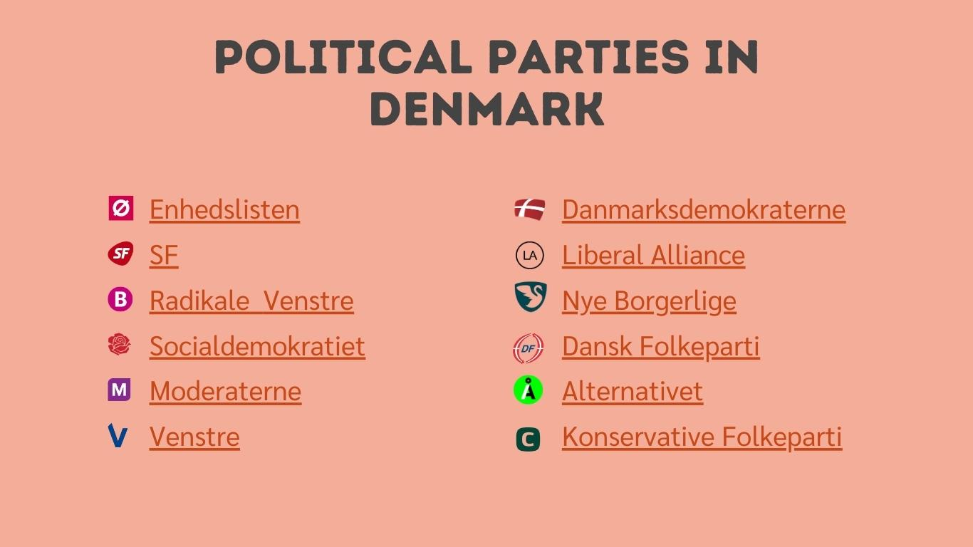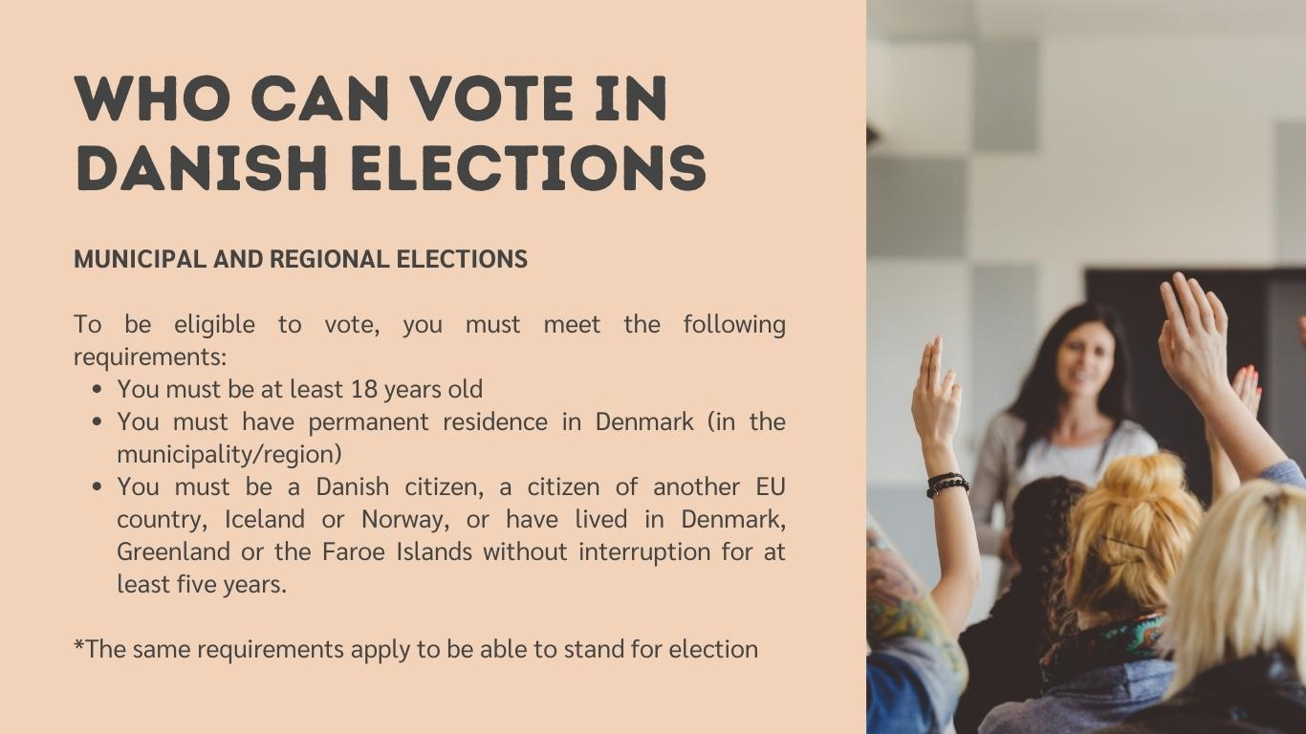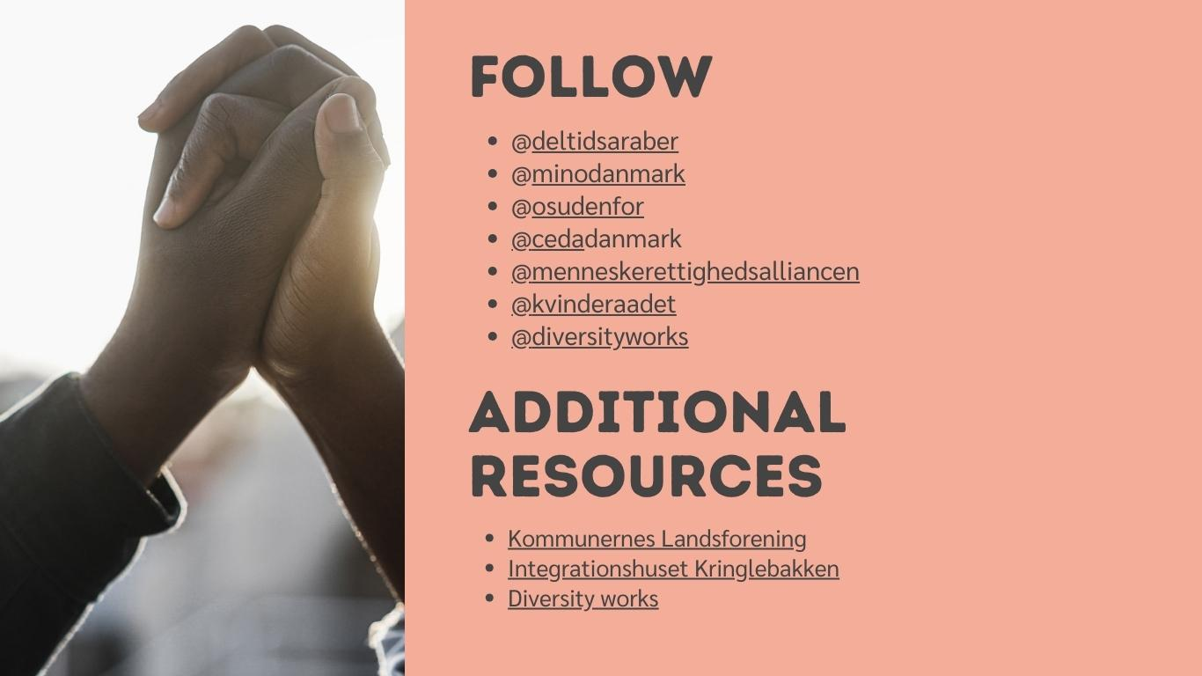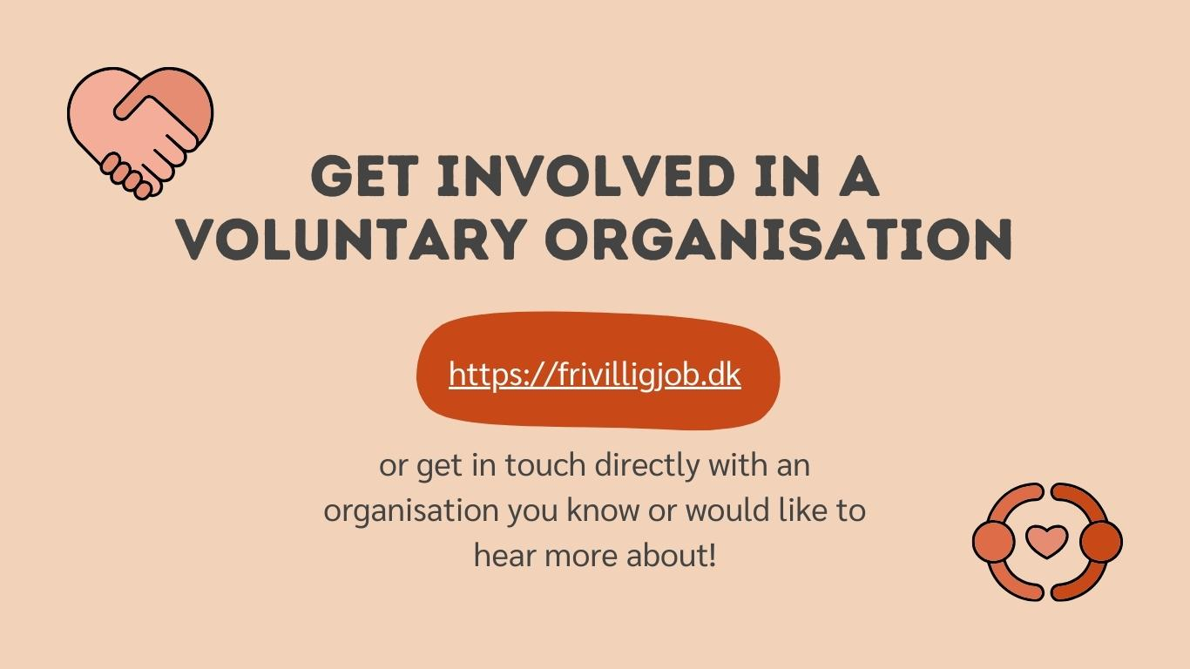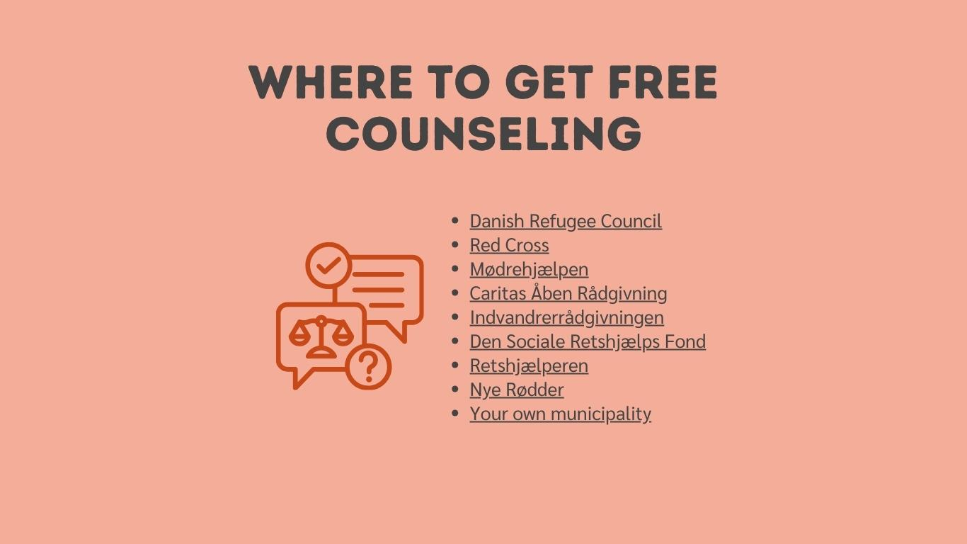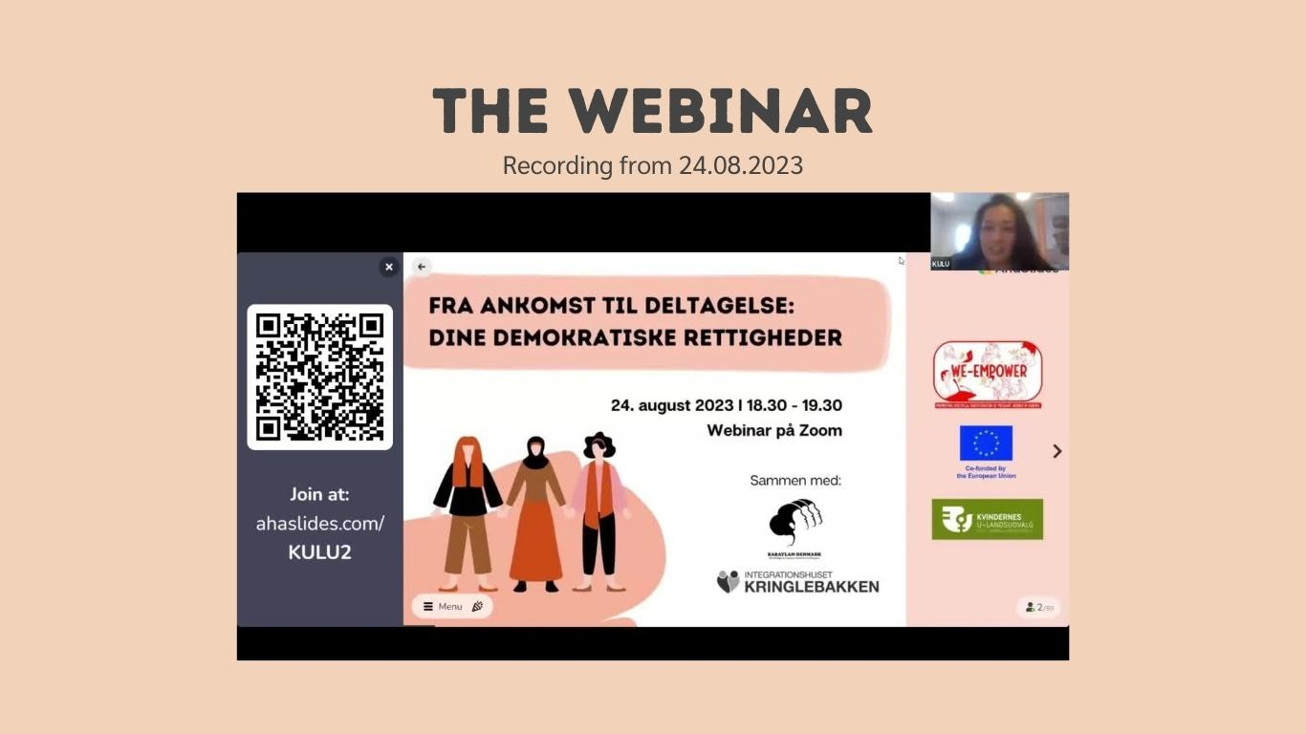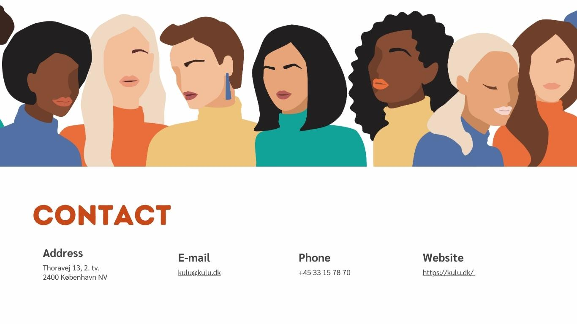 | As the topic of democratic rights is a more widespread topic, more resources are available both digitally and physically in Denmark. For this reason, the structure has been personalised and adapted to existing resources.  We created the following categories:  - “Your voice & vote make a difference” linking to a campaign and podcast for previous elections in Denmark. The campaign entitled “Din stemme gør en forskel” is a play on words, as stemme in Danish both means vote and voice. The aim of the campaign and the podcast was to incentivise migrants in Denmark to use their vote (and voice).  - “Political parties in Denmark” showing the spectrum of and linking to the website of existing political parties in Denmark.  - “Who can vote in Danish elections” to highlight that also migrants can vote in municipal and regional elections in Denmark.  - “Follow” linking to suggested accounts of migrant voices in Denmark and across Europe as well as organisations working with migrant women.  - “Additional resources” linking to additional institutions and organisations working with migrant women.  - “Get involved in a voluntary organisation” to inform the audience about the opportunity and the importance of becoming a volunteer in Danish society.  - “Where to get free counseling” linking to different organisations in Denmark that offer free counseling in terms of democratic rights and processes.  - “The webinar” with the webinar recording.
Topic 3: Storytelling as a Tool (images in carousel format if possible)
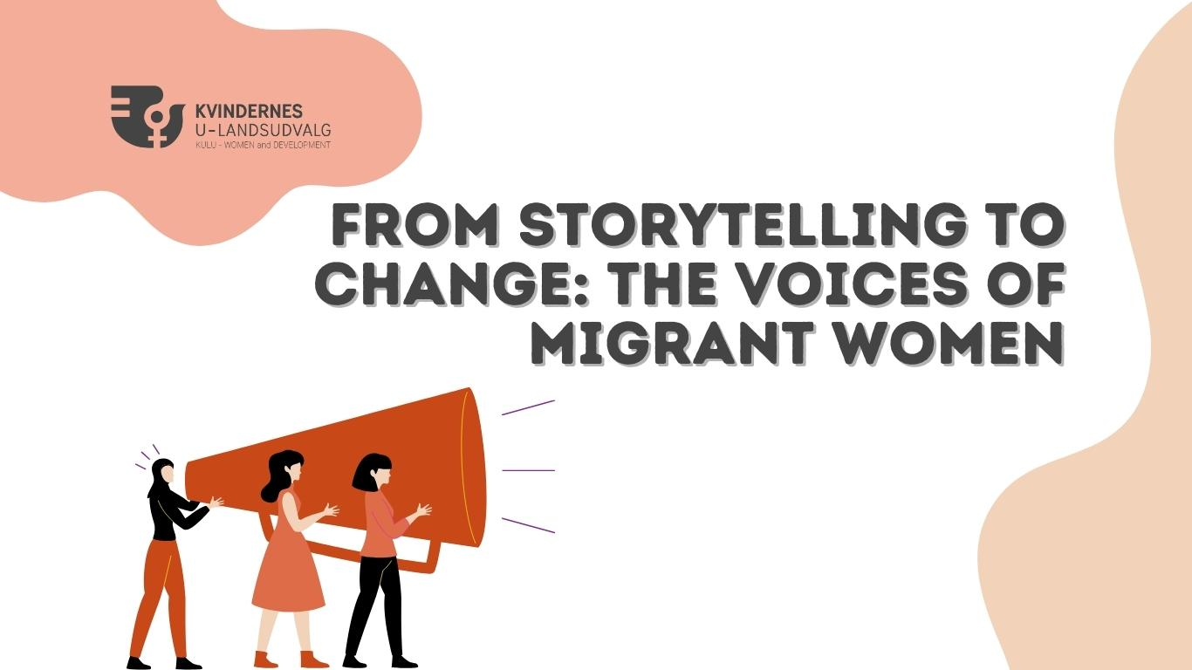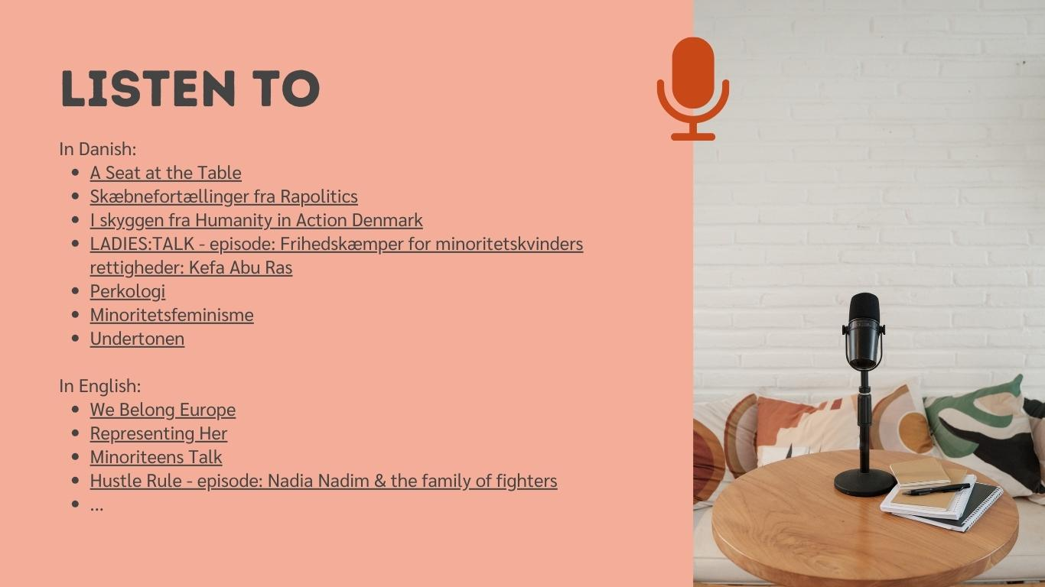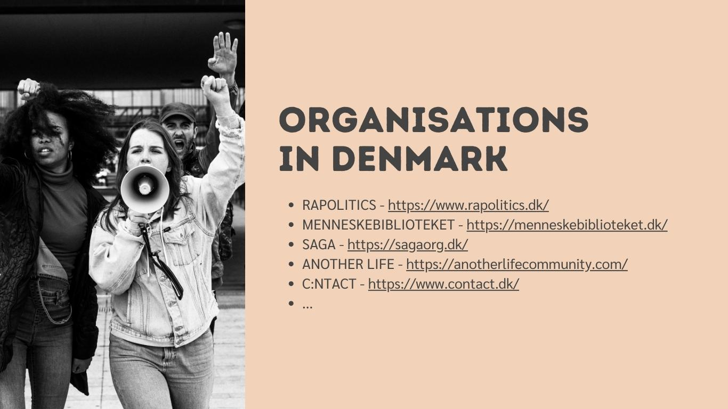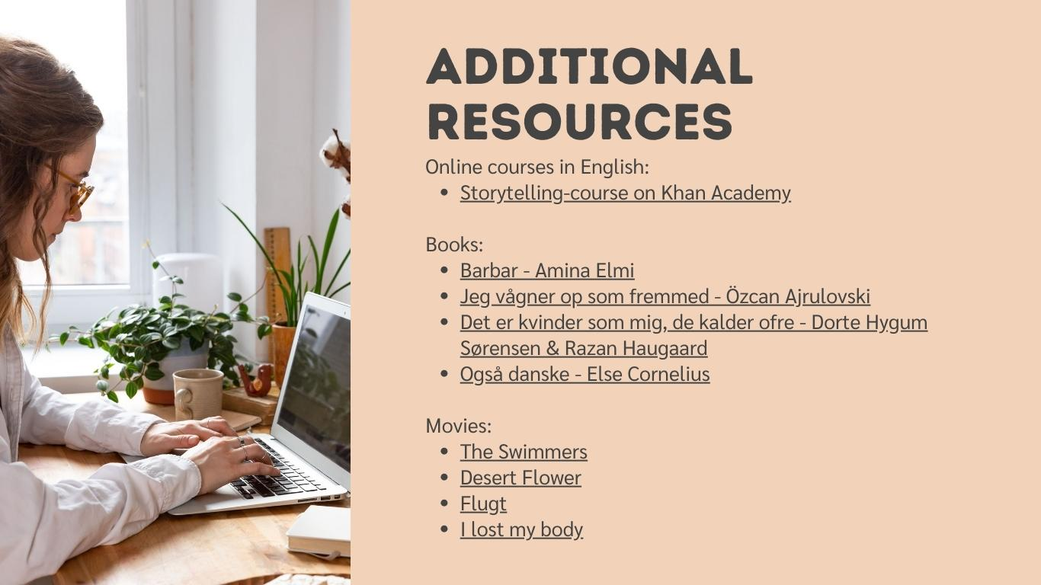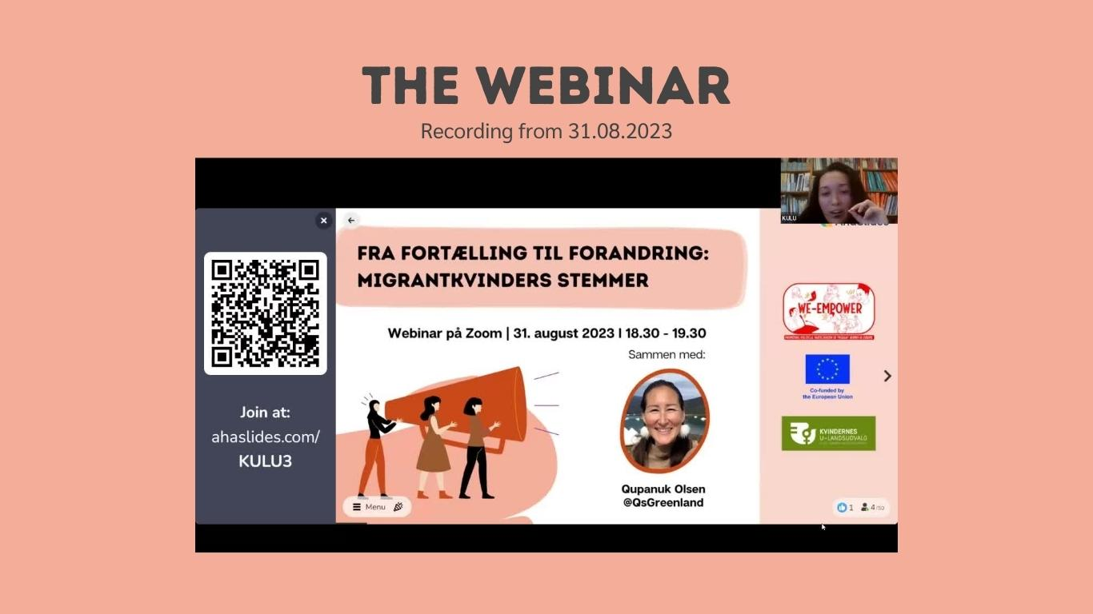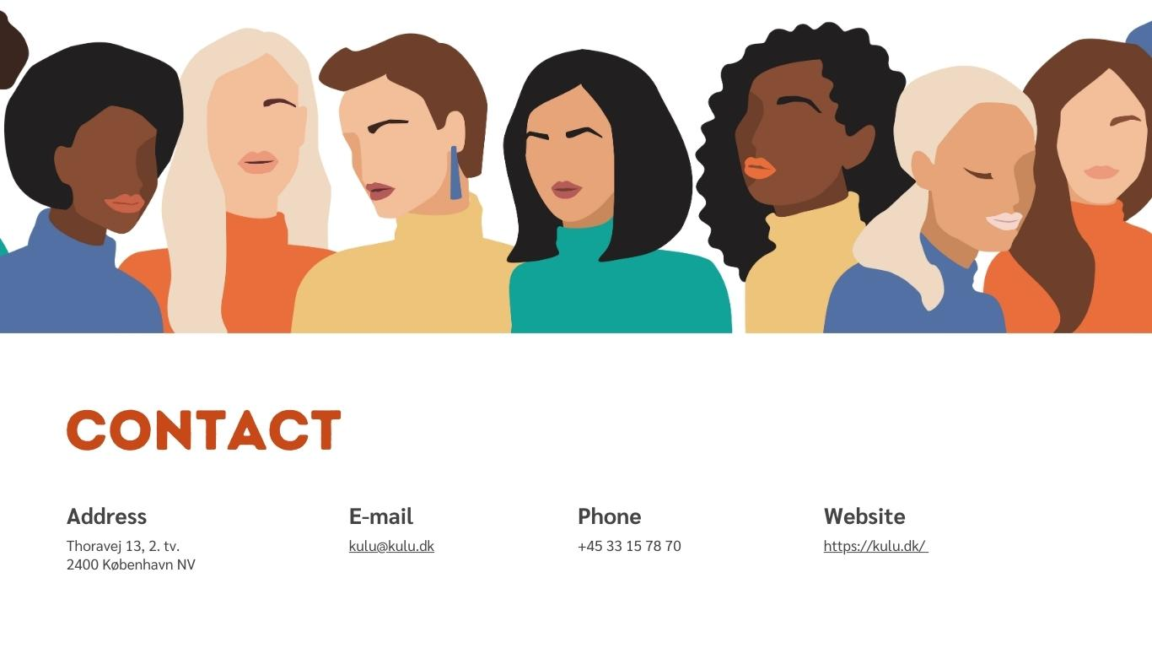 | For the storytelling resources, we created the following categories:  - “Listen to” with podcast suggestions in both English and Danish.  - “Organisations in Denmark” linking to various local NGOs and associations that specialise in storytelling and migration, and that organise events that might be appealing to migrant women in Denmark.  - “Follow” linking to suggested Instagram accounts that advocate for migrants’ rights in both Denmark and across Europe.  - “Additional resources” with free online courses, suggested books and movies that highlight stories of migrant women.  - “The webinar” with the webinar recording.
Creating a resource platform is an invaluable endeavor that can significantly enhance your organisation's impact and outreach.
A well-crafted resource platform not only serves as a repository of knowledge but also as a catalyst for engagement and change. It has the potential to support continuous learning, promote collaboration, and drive meaningful conversations. Remember, the success of your platform lies in its relevance, accessibility, and the value it provides to its users.
____________________________________________________________________________

Engaging with user-generated content and feedback
Engaging with your audience through user-generated content and feedback can significantly enhance the effectiveness and relevance of your resource platform. If time and resources allow, consider integrating mechanisms for collecting and showcasing feedback, stories, and contributions from your target group. This not only enriches the platform's content but also fosters a sense of ownership and community among users.
Encourage your audience to share their experiences, insights, and resources. Utilise tools such as forums, comment sections, surveys, and submission forms to facilitate this interaction. By regularly reviewing and incorporating user feedback, you can continuously improve the platform and ensure it meets the evolving needs of your audience. Engaging with user-generated content also provides valuable insights that can guide future projects and initiatives.
Ultimately, a resource platform that actively involves its users can become a dynamic and responsive hub, driving deeper engagement and making a more significant impact.

